**Mehdi Miraç ARAT / 2121251023**

**Computer Programming II Laboratory**

**Final Exam**

**21/06/2023**

**Computer Programming II Laboratory Project Report**

**Personnel Advance Tracking System**

1. **Aim of The Project**

A personnel advance tracking system is a software or system used to record and manage the advances received by employees in a workplace. This system is used to record employees' advance requests and the advances they receive, to control whether the advances have been paid or not, and to manage the calculation and management of advances.

The advance tracking system is typically used by human resources departments and is used in employee salary calculations. This system facilitates the tracking of financial transactions of personnel in the workplace, improves communication and data sharing between management and personnel.

The advance tracking system is important for the financial management of a workplace and is used to control workplace costs, calculate employee salaries accurately, and manage financial processes in the workplace.

1. **Program Objects and Relationships**

**2.1) The main purpose of use of Personnel Object:**

* This is a Java class called Personnel which extends PersonnelPage for use table model. It has private instance variables name, surname, password, Salary, and Advance. It also has public getter and setter methods for each of these variables.
* This class represents an employee in the system and contains information such as their name, surname, password, salary, and advance. The information can be set and retrieved using the getter and setter methods.

**2.2) The main purpose of use of Admin Object:**

* This code defines a Java class called Admin. The class has two private instance variables, username and password, which are both of type String.
* There are two constructors defined for this class. The first constructor takes two arguments, username and password, and assigns the values of these arguments to the instance variables. The second constructor is a default constructor that does not take any arguments.

**2.3) The main purpose of use of User Object:**

* This is a Java code for a class called "User" that extends another class called "UserLogin". The class has two methods: "kullaniciGiris" and "adminGiris" which both take two String arguments for username and password.

**2.4) The main purpose of use of Manager Object:**

* This code serves the purpose of defining a data model for the Manager_1 class. This class represents a manager and includes properties such as their ID, name, and surname. It is used to store, access, and manage information related to a manager.
* The functionality provided by this code is as follows:
* It provides properties to store the ID, name, and surname of a manager object.
* It offers getter and setter methods to access and modify the properties of the manager object.
* The equals() method can be used to perform equality checks between manager objects. It compares the IDs of the objects to determine if they are equal.
* The hashCode() method can be used to compute a unique hash code value for the manager object based on its ID.
* The toString() method returns a string representation of the manager object, primarily displaying its ID.
* Overall, this code establishes the Manager_1 class as a foundational structure for managing and manipulating manager-related data. It can be used to store manager information in a database or work with manager objects in various contexts. The class provides basic functionality for accessing and modifying the properties of a manager object and supports equality checks and string representations of the object.

1. **Rules:** Write your comprehensive rules (at least 5)

* The "kullaniciGiris" method which is at User class iterates over a table or model to check if the given username and password match with any of the rows in the table. If a match is found, it creates an instance of the "Personnel" class, sets its attributes using the values from the matched row, and displays a GUI window called "PersonnelPage" with the personnel information. If the "status" attribute of the personnel is "Accepted.", it also displays a message indicating that the personnel's advance request is accepted. Finally, it closes the login page and returns true.
* The "adminGiris" method which is at User class checks if the given username and password match with the values stored in an instance of the "Admin" class. If they match, it returns true; otherwise, it returns false.
* The Admin class has three methods defined.
  1. The getUsername() method returns the value of the username instance variable.
  2. The setUsername() method takes a String argument and sets the value of the username instance variable to the value of the argument.
  3. Similarly, the getPassword() method returns the value of the password instance variable, and the setPassword() method takes a String argument and sets the value of the password instance variable to the value of the argument.
* The getter and setter methods at Personnel class allow other classes to access and modify the private instance variables. For example, the getName() method returns the value of the name variable, while the setName() method sets the value of name to a given input parameter.

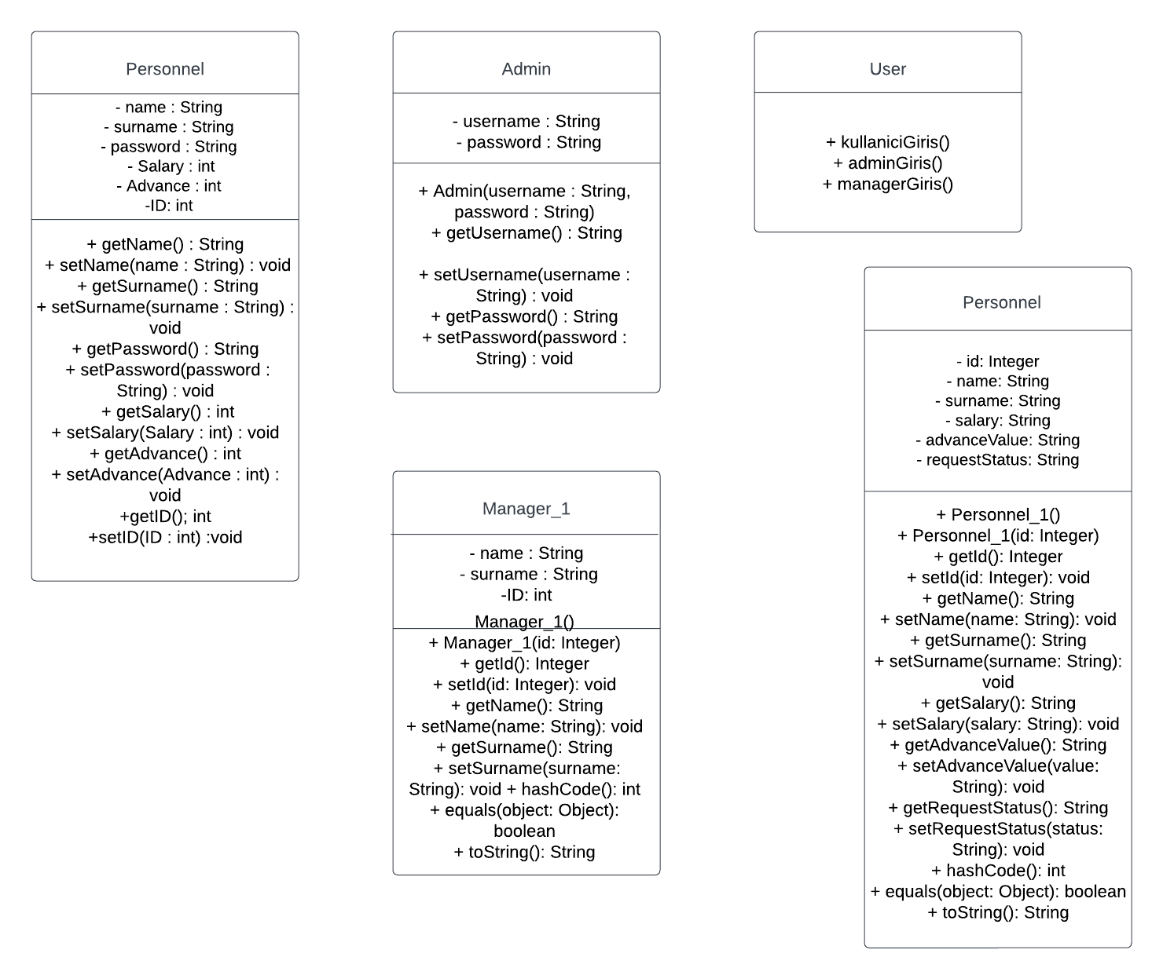 **4.** **UML DIAGRAM**

**Info about UML:**“+” means, the variable or method is “public”.

“-“ means, the variable or method is “private”.

**5.** **DATA MODEL**

metin, ekran görüntüsü, tasarım içeren bir resim

Açıklama otomatik olarak oluşturuldu